**Lab 9:**

**BJT Amplifier Design**

Name: Wan-Yu Liao

ECEN 325 Section 514

TA: Mandela

Lab Date: November 1, 2019

Lab Report Due Date: November 8, 2019

**Calculation**

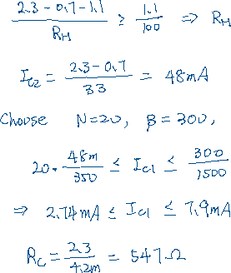

**Simulation**

(I redo the simulation, since the simulation in pre-lab was wrong)

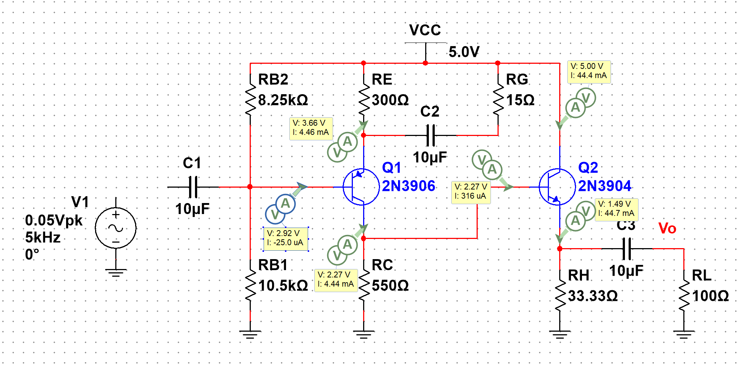

**Figure 1:** DC solutions

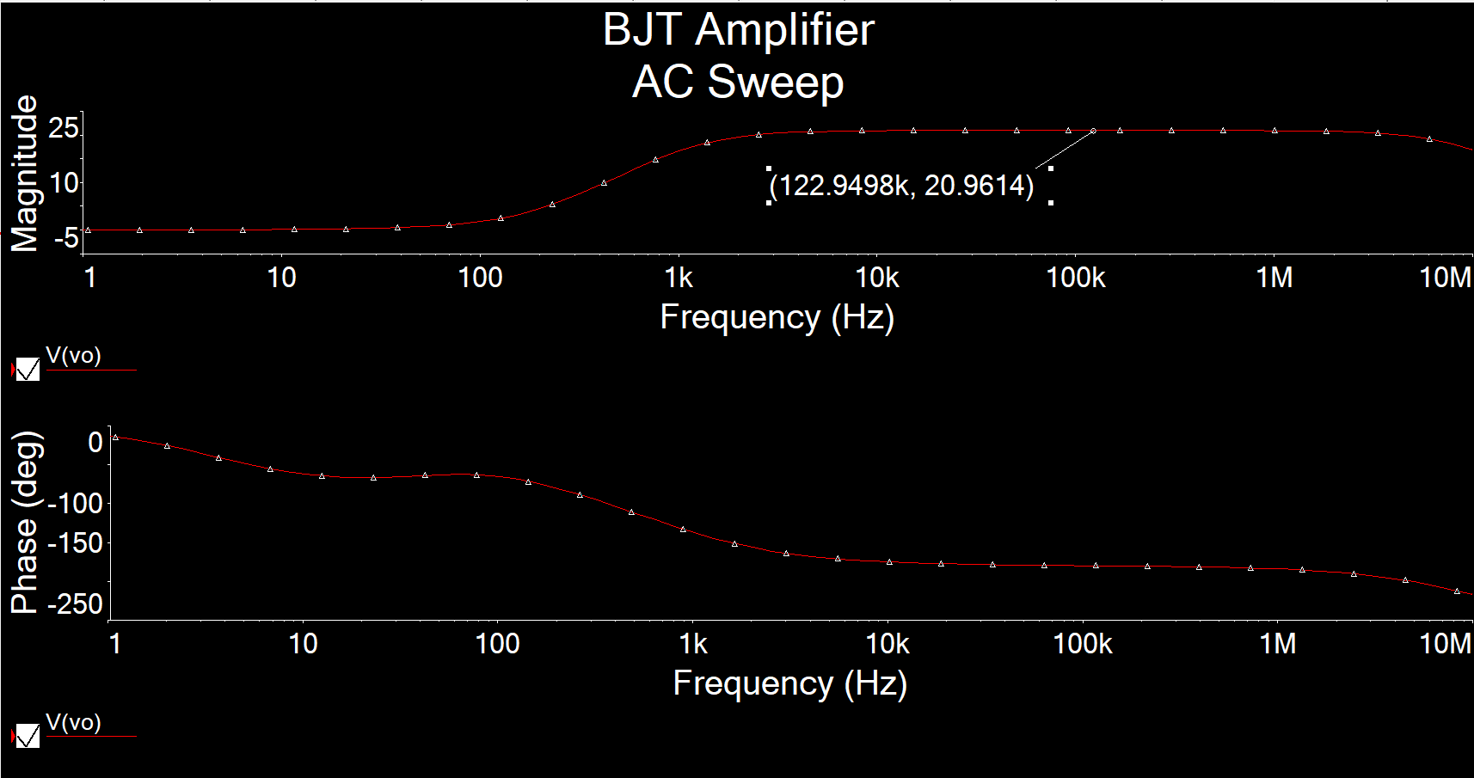

**Figure 2-1:** AC Simulation of Av

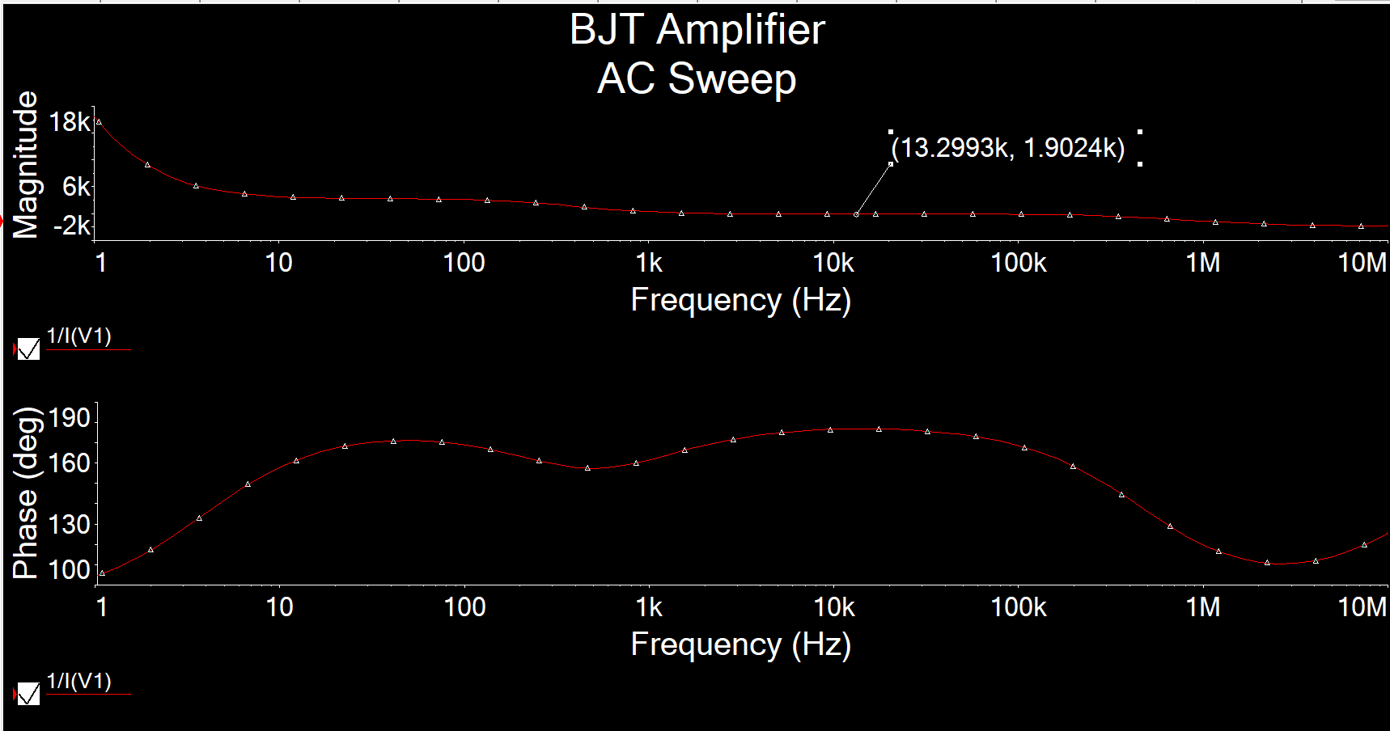

**Figure 2-2:** AC Simulation of Ri

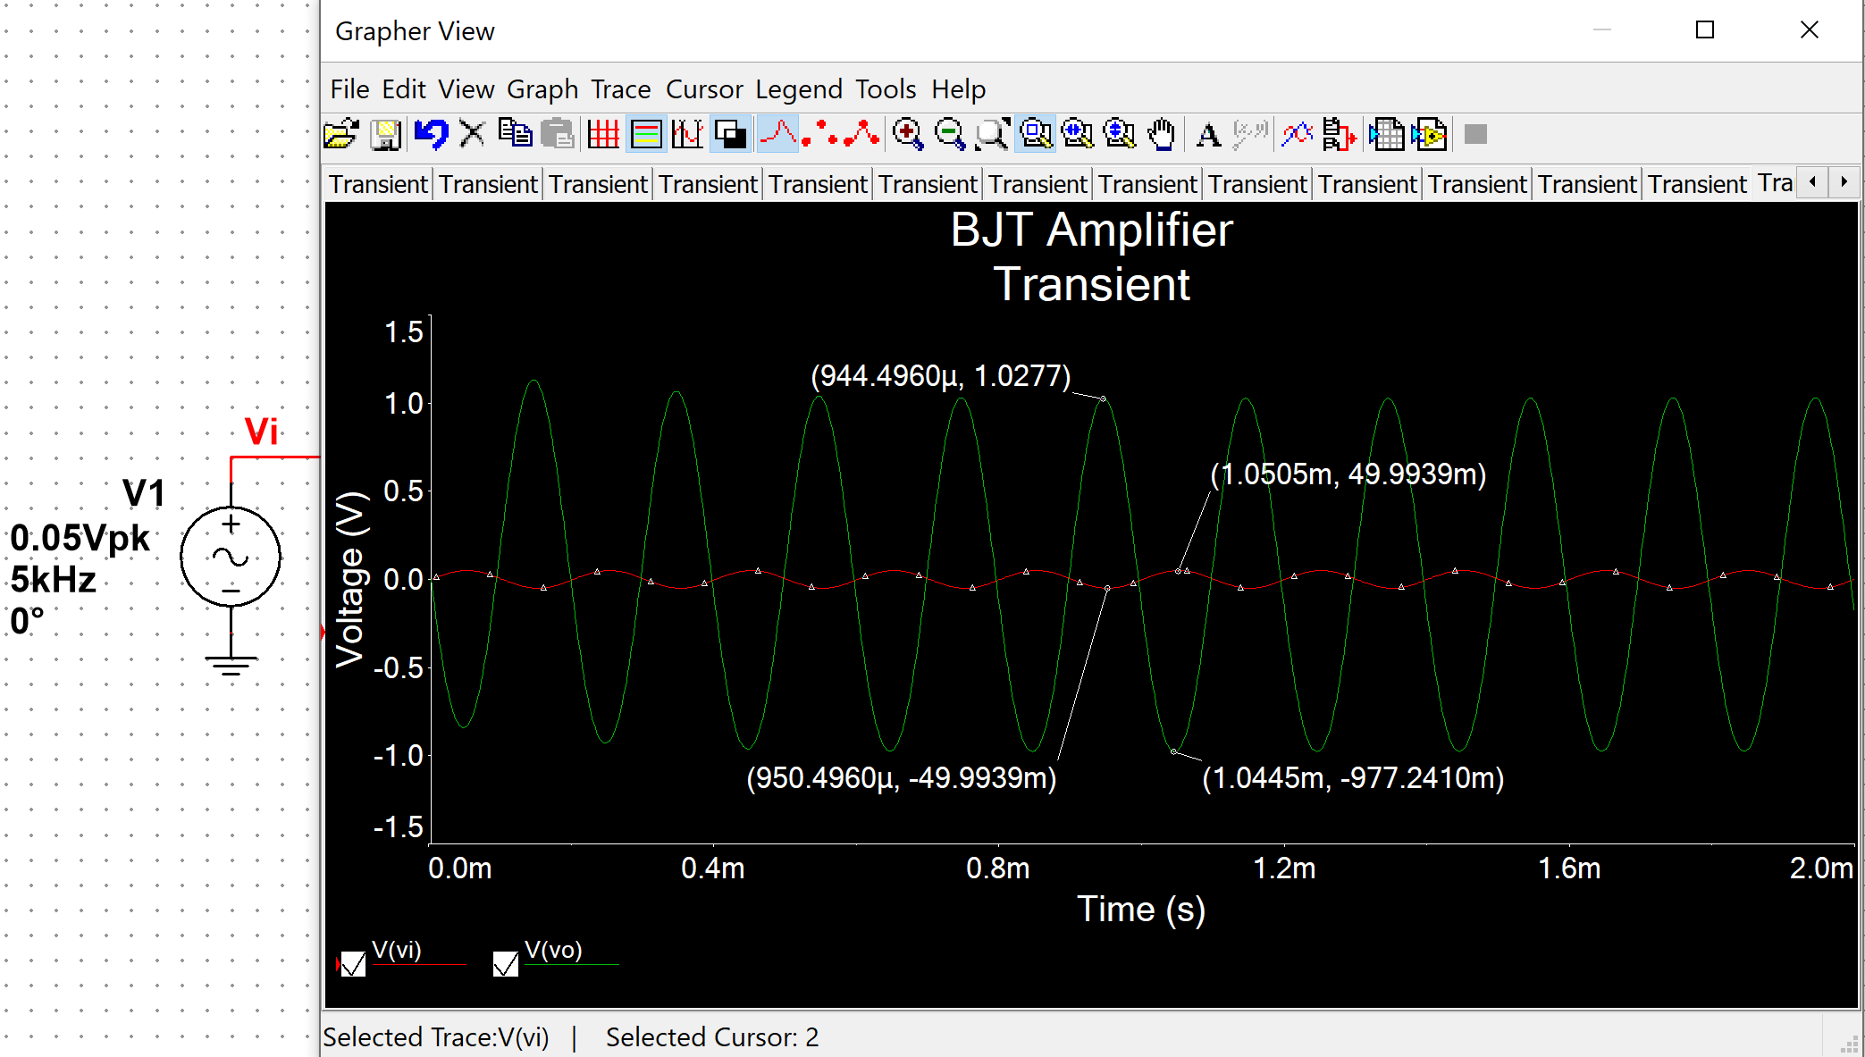

**Figure 3:** Time-domain waveform

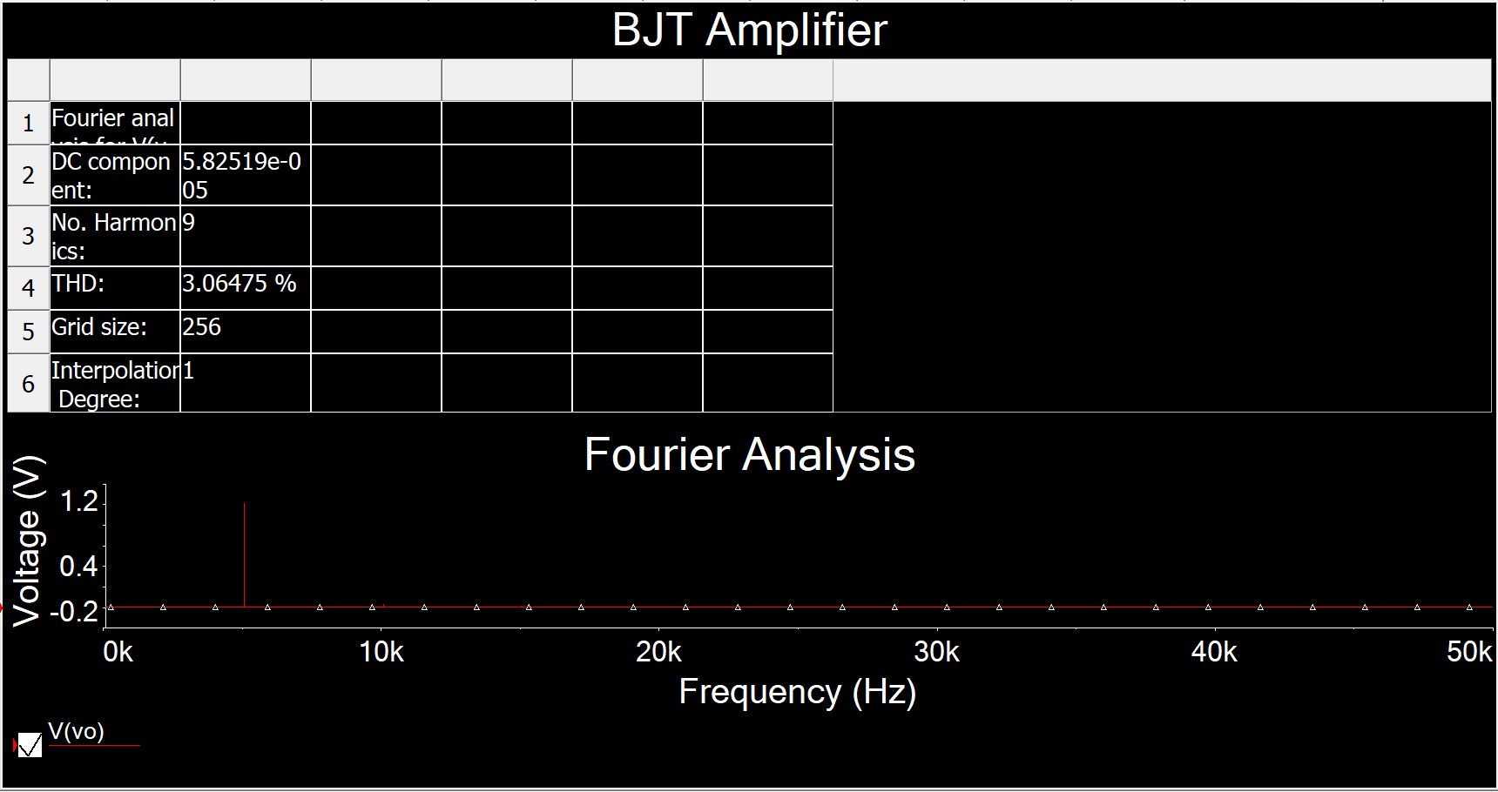

**Figure 4:** THD

THD = 3.06% which is less than 5%

**Measurement**

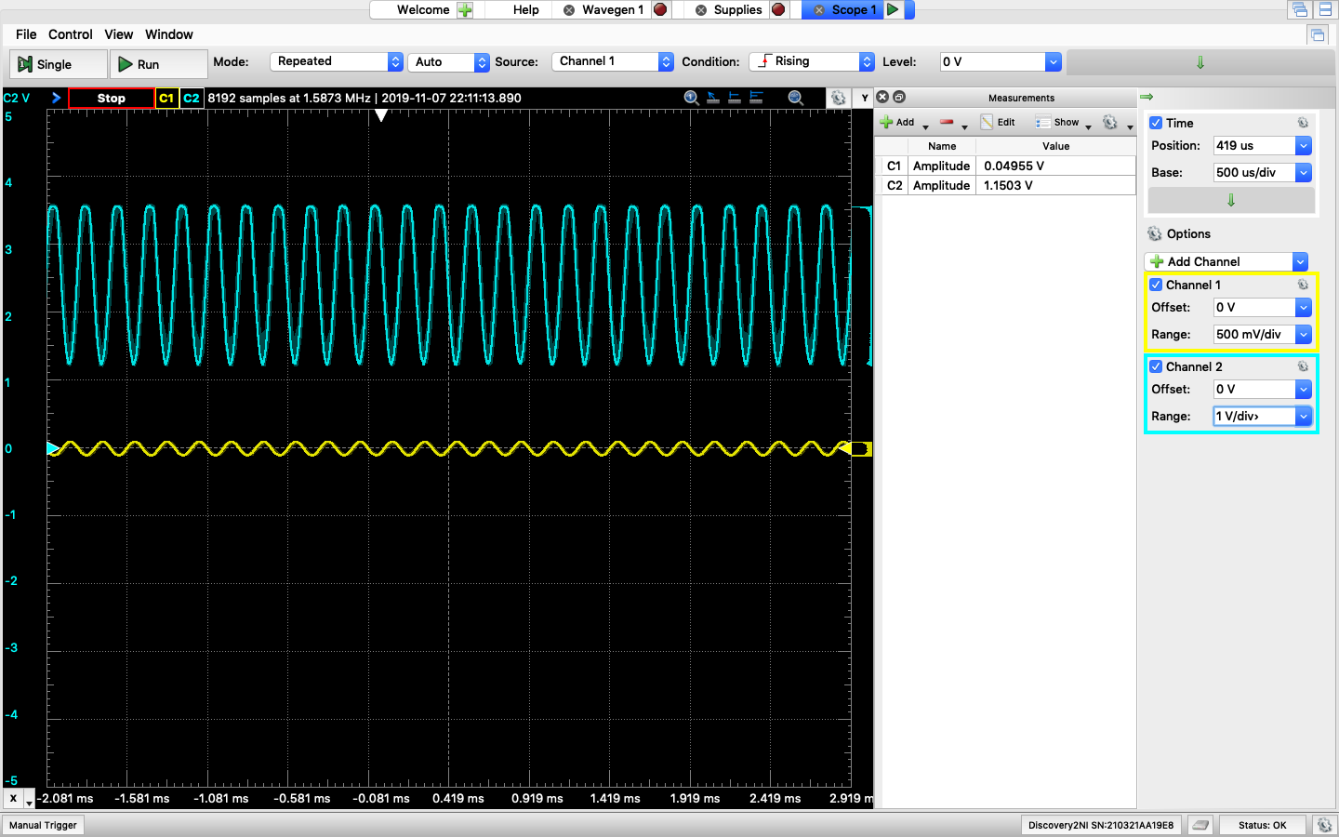

**Figure 5**: Stage 1 Gain

(I change RG from 15Ω to 3.33Ω since 15Ω didn’t give me gain of 20)

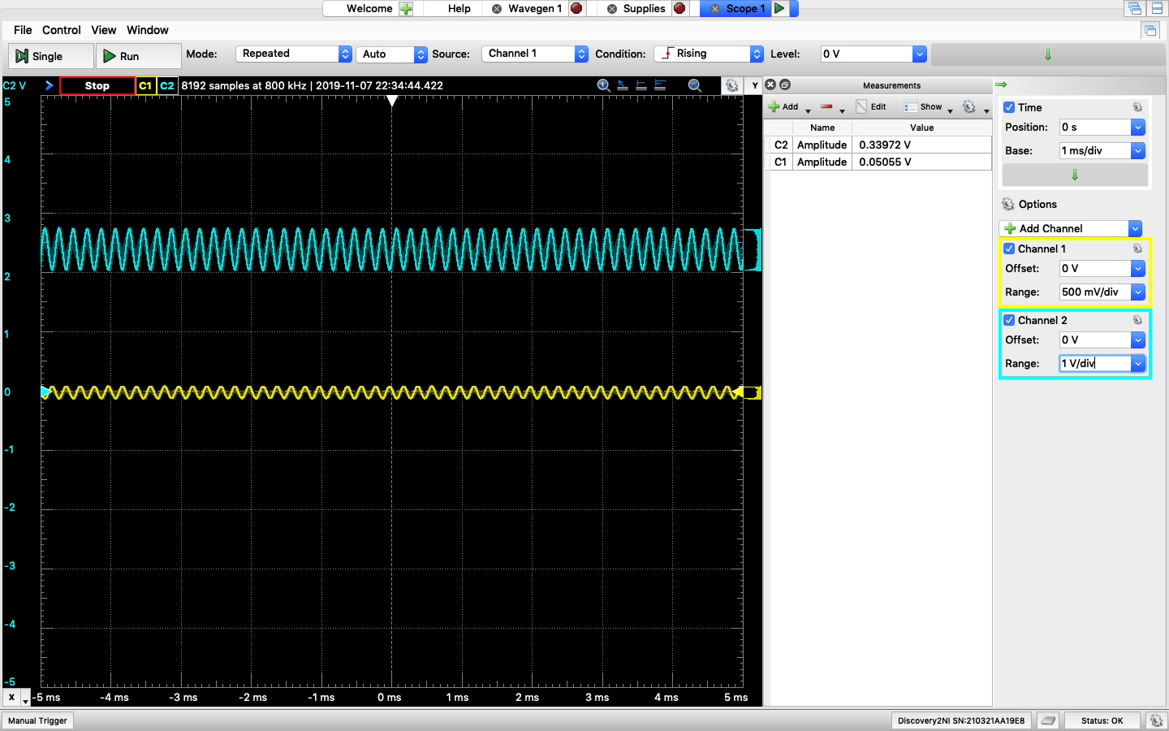

**Figure 6**: Stage 2 Gain

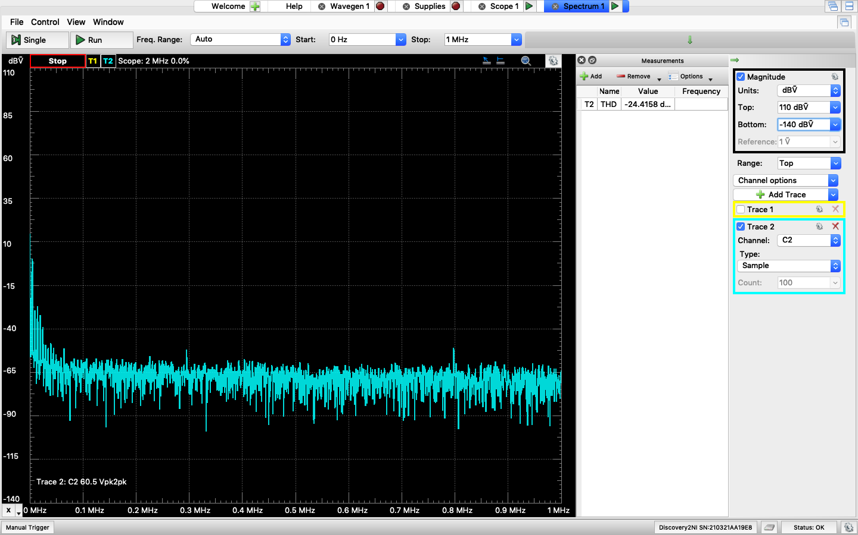

Figure 7: THD at Stage 1

THD = -24.4158dB = 0.06015 = 6%

**Table**

|  |  |  |
| --- | --- | --- |
|  | Calculation | Simulation |
| VRE | 1.3V | 1.34V |
| VRC | 2.3V | 2.27V |
| IC1 | 4.2mA | 4.44mA |
| IC2 | 48mA | 44.4mA |

**Comment**

The measurement part is not correct for several reasons. First, the Analog Discovery 2 can only handle up to 250mW. To make stage 2 have gain of 20, the circuit needs to be modified to reduce the power consumption at stage 1. Second, the breadboard, resistors, transistors, and capacitors in the real world are not ideal. So that why not everything work as simulation.